RULES
THEME
There were very strong archers ( means Kemankeş which is old Turkish word , keman=bow and keş=a person pulls something ) in Ottoman era. Sometimes when they would pull the bows so strongly that bow ends (means “toz” in Turkish) would be broken. Therefore these archers called as “Tozkoparan” which means a person who breaks tips of bow. Theme of this category was inspired by these strong archers called Tozkoparan.
This competition is carried on with robots that are built by using mechanic,software and sensor tecnologies. Competition frame consist of following a route , shooting a target and finishing the rouse as soon as possible. Robots will get scores according to successful levels and target scores.
- OBJECTIVE
In this category, archer robots try to follow white lines on black colored platform and detech the colors, shoot to target board and return to finish gate in shortest time without mistake.
Competition will be held over 3 rounds according to point ranking. Robots try to complete the designated track in the 1st round and other rounds with the highest score and in the shortest time. The tasks on the track and the arrow shot to the target are evaluated with points. The robots among the first 64 robots in the point ranking go to the 2nd round. Round 3 is the last round and the first 16 robots in the point ranking at the end of the 2nd round will participate in this round. In the 3rd round, the first three ranked robots according to the point ranking will win the competition as 1st, 2nd and 3rd. Depending on the number of robots participating in the competition, the number of robots in the 2nd and 3rd rounds can be changed by technical advisors and referees.

ROBOT

Robots will move autonomously and shoot arrows. There is no limit for robot size. But its size (include shooting mechanism ) should be designed as pass through start/finish gates. Robots that can’t pass the gates will be disqualified.

ARROW

Arrow consists of 4 parts(figure 1). These parts are wooden body, arrowhead printed PLA in 3d printer, polythelen foam and velcro tape. Arrow body is made from circular shape wooden with 9mm diameter,180mm lenght. Arrowhead is printed PLA material with 28mm diameter, 14.75mm length, conic shape by 3D printer. Polythelen foam (28-20,5 mm diameter, 12mm thickness, conic shape) is sticked to make it flex. Velcro tape (36mm diameter, female side) is sticked on this foam. To make easy sticking, tape is attached to the holes of PLA material on the arrowhead with rope. Weigth of arrow is 8 ±0,5 gr and it is given by judge right before starting game and placed to shoot mechanism. Each robot will shoot it autonomously. When arrow sticks to target circles, it gets score. If it is not stick on target board and drops down, score will be determined by video camera.

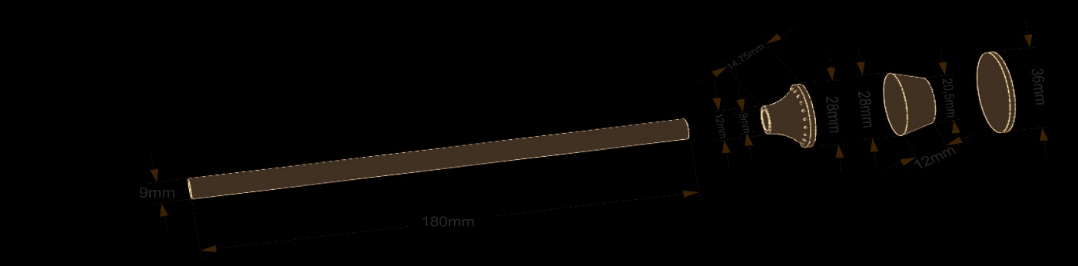

Figure-1 Arrow dimensions

INFORMATION ABOUT SHOOTING MECHANISM :

Arrow dimensions are shown at figure-1. Competitors will design a shooting mechanism that able to throw such arrow from a certain distance and height to target board. Competitors can design it as they wish and they will asemble this mechanism on robot ( robot needs to pass through start and finish gates.)

TARGET BOARD

Target board (700x700mm) will be made by chipboard, its surface will be covered with polythene foam 12mm thickness to provide flexibility. Foam surface will be covered with velcro tapes (male side) . Target board will be placed 400mm high to facilitate shooting process and provide good view for spectators. To do this, it will has legs. Target surface is combination of 5 nested circles (biggest one has 600mm diameter) with different colors drawn on target board to able to scoring. On the target board.

These colors are yellow, red,blue,black and white from center to outer. If arrow hits on the lines seperating circles, it is assumed that hits circle which has higher score. Colors and scores are shown below:

Colours and scores:
Score | Colour
100 | Yellow
80 | Red
60 | Blue
40 | Black
20 | White

Target board dimensions:
Target dimensions are calculated by using diameters of 5 circles which represent scores. Tolerances of each diameter is ±3mm.

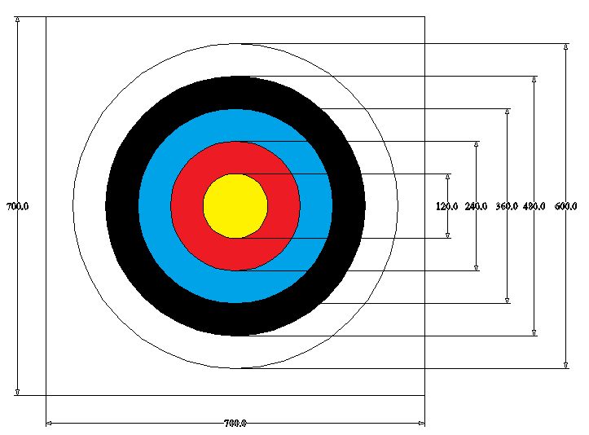

Figure 2- Target board
6. ELIMINATION TRACK
Informations
- Tracks on platform are formed with white lines on black opaque PVC foam. The path inside the letter C, which is only made of white foil, is in the form of a black line.
- The platform consists of two parts: 2900mm x3600mm sized 18 mm thick chipboard, 2900x3100 mm sized part made of 5 mm thick black matt dacota material and 1800x1000 mm part on which the 700x700 target board is located. For the race start area where the start gate is located and the race finish area where the sensors to end the competition are located, 2 pieces of 600x500 mm dacota material were also used. The joints of the parts forming the road were covered with black matt foil. On three sides of the chipboard used in the first part of the palletform, except for the start and end sides, a border of 18 mm thick and 68 mm high (the height on the competition floor will be 50 mm) was made. Together with the borders, the size of the first part is 2936x3618 mm. The total area covered by the platform is 5418x2936 mm. Figure 3, Figure-4
- The road lines on the platform are made of 20±2 mm thick white matt foil and the black road lines inside the letter C which is made of white foil are made of 20±2 mm thick black matt foil.
- The coloured region with the number 100 and the letter C on the Dakota ground consists of four different colours. Starting from the entrance part, the area with the number 0 in the first row is green, the area with the number 0 in the second row is blue, the area with the number 1 is red, the area with the letter C is white and all of these coloured areas are made of 2 mm thick matt foil.
(Green-Blue-Red-White)
When the robot detects the green coloured region by following the white path line, the green led will turn on and continue to light until the blue region. Then the robot will move to the blue region and when it detects the blue region, the green led will turn off and the blue led will light and the blue led will continue to light until the red region. Then the robot will move to the red region and when it detects the red region, the blue led will turn off and the red led will light up and the red led will continue to light up until the white region, that is, the letter C. At the same time, the robot will stand in the red coloured number 1 and shoot an arrow at the target board. After shooting, it will find its way back. Then it will follow the black path inside the letter C made of white foil and reach the exit gate by detecting the white path after the end of the black path.
- As shown in figure 3, green and blue zones are formed as shape “0” (800 mm x 800 mm) and no foil in the center of shape. Red zone has dimensions 800mm x 600 mm and it is formed as shape “1” , White zone which is as shape “C” has dimensions 800mm x 600 mm
- There will be two elimination routes on the platform as to be symetrical to each other. So they are called route-A and route-B. Total area include location of target board is 7418*7836 mm dir. Figure-3, Figure-4
- There is one start gate with white colour for each route. Gate will be opened by pressing start button and stopwatch runs for counting time. Height from its top is 250mm at opened position of gate and height from its bottom is 15mm at closed position of gate and width of gate is 600±3 mm.
- Stopwatch will start counting when judges pressed start button and the gate opened. It will stop counting when robot arrives finish gate by sensor’s detection. Finish sensor which is transciever is placed between gate towers and 15mm high.
- Target board is located directly opposite of red zone. It is 1918±5mm far from red zone . Bottom edge of target board is 400 ±3 high from ground.
- Judges will determined which route that robot will use will by using draw lot method.
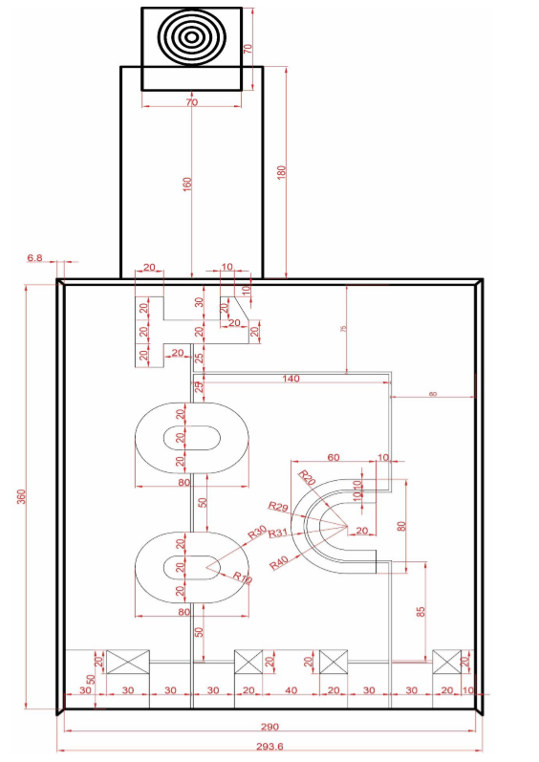
Figure 3: First round route dimensions

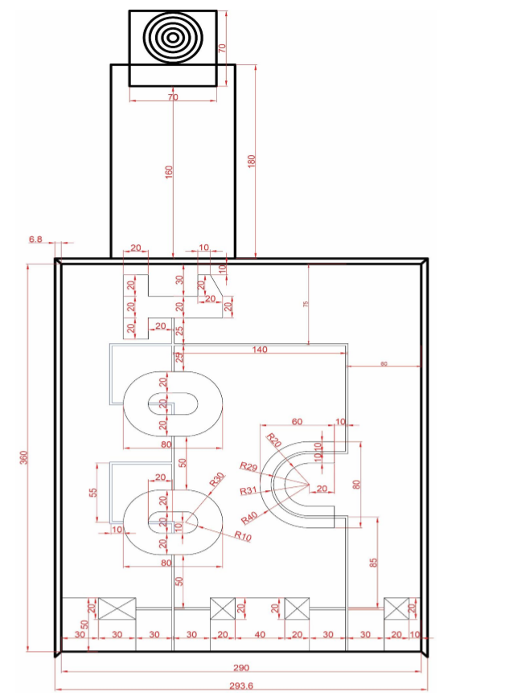
Figure 4: 2nd and 3th rounds route dimensions

Game and scoring
  - Each robot races in turn, this order is determined by the draw. So which route that robot will race is determined. (route A or route B)
  - After controlling robots on check-desk, judge gives one arrow to both robots. Competitor installs arrow into shoot mechanisms of robots and put robot on start place . Game start with judge’s order. After starting, if arrow drops down from mechanism or robot shoots arrow from out of shooting zone, it will be assumed as “failure“ and permission for manual intervention wil be given. Then, arrow will be put again into mechanism.
  - Robots reach colored zone by following while lines , detech green colour and turn on green led. After that, they continue until blue zone and detect blue color and turn on blue led, After that, they continue until red zone and detect red color and turn on red led, wait inside red zone. After shooting arrow to the target board, robots rearch to white zone by following white line. Then follow black line. Later, they go to finish gate by following white lines. When they reach finish gate, game will be over.
  - Time will be recorded by stopwatch. Stopwatch starts by pressesing start button and opening automated gate by judge and stops when robot arrives finish gate by sensor’s detection.
  - Each robot has to finish game in 180sec. If robot cannot finish in this time, stopwatch stops counting and robots take place in ranking list according to its score so far.
Scoring:
  - Robots have to move right directions. At the beginning , 100 base points is given to robot. Robot will be evaluated for 7 steps from start to finish as 100 points. Points given for shooting arrow will be added to this point. Best score on target board is 100point so the highest score which can be given is 300 points. Robots which are disqualified gets 0 point.
  - Competitor has 5 rights to make intervention. After 5th intervention, if robot can’t do the task , it will be disqualified. These robots are also placed on the ranking list and their times are assumed as 180sec.
  - If robot makes mistakes during the game , -5 failure point is given for each manual intervention and other failures ( such as no shoot, not led light up etc). In any stage, only one failure point for manual intervetion is given (no matter how many times( max. 5 times))
  - In case of robot doesn’t do its 7 tasks in order of given order , make short cut, doesn’t move at start point, drops arrow from mechanism, shooting arrow from outside of red zone , judge gives permission for manual intervention and robot continues from failure location. -5 point is given ( if it not given so far ) in this moment.
Competition Steps:
1. step- Start gate;
After the start gate is opened, 10 points are awarded to the robot that runs and crosses the start line. Figure-5. Within 10 seconds, the robot that does not start or does not start and does not cross the start line is considered to have used the 1st hand intervention right. If the robot does not cross the start line in every 10 seconds after the 1st manual intervention, it is considered to have intervened manually and in the case of the 6th manual intervention, that is, if the robot does not cross the start line in the 60th second, the competition is terminated by the referee and only 100 points are given to the robot. In case of manual intervention, if the robot crosses the start line, one -5 point is given as an error point.
2. step – white line;
If the robot follows the departure line and reaches the green zone, 15 points are awarded. No more points are awarded until the finish line. If the robot leaves the white line in the specified direction of movement until the finish line and cannot find it again, the robot is put back on the track from where it left; in the meantime, the time continues to run. In case of manual intervention, 5 points are given once as error points.
3. step –Green zone;
When the robot reaches the green zone, 15 points are given if the green led lights up continuously until the blue zone by detecting the green zone and if it passes the green zone and then follows the white line to the blue zone border. If the green led does not light continuously until the blue zone after reaching the green zone, -5 points are given as error points. In case the robot fails to reach the blue zone limit, the robot is taken with the referee's signal and given the right to intervene manually and is put back on the track from where it came out. In case of manual intervention, -5 points are given once as error points.
4. step –Blue Zone;
When the robot reaches the blue zone, 15 points are given if the blue led lights up continuously until the red zone by detecting the blue zone and follows the white line after passing the blue zone and reaches the red zone border. If the blue led does not light continuously until the red zone after reaching the blue zone, -5 points are given as error points. In case the robot fails to reach the red zone limit, the robot is taken with the referee's signal and given the right to intervene manually and is put back on the track from where it came out. In case of manual intervention, -5 points are given once as error points.
5. step -Red Zone;
When the robot reaches the red zone, 15 points are given if the red led lights up continuously until the end of the red zone by detecting the red zone and the end part of the robot stops before passing the red zone. If the red led does not light up after reaching the red zone, -5 points are given as error points, and if the robot cannot stop in the red zone where the arrow will be shot at the target in any way, the robot is taken with the referee's signal and the right to intervene manually is given and the robot is placed on the white line before entering the red zone. In case of manual intervention, -5 points are given once as an error point
6. step-Shooting;
If the robot shoots an arrow in the red zone, then moves and reaches the border of the white coloured letter C, 15 points are awarded. In case the robot fails to shoot an arrow, -5 points are given as error points, in case the robot fails to reach the limit of the letter C in any way, the robot is taken with the referee's signal and the right to intervene manually is given and the robot is put back on the track from where it came out. In case of manual intervention, -5 points are given once as error points.
7. step – C shape and white colored zone and finish;
When the robot reaches the white coloured area with the letter C, 15 points are awarded if it follows the black line and passes the finish gate by following the white line. In case the robot leaves the black line in the specified movement direction and cannot find the black line again, it is put back on the track from where it left, meanwhile the time continues to run. In case of manual intervention, -5 points are given once as error points. When the robot reaches the finish gate, the stopwatch stops counting with the detection of the sensor and the competition ends.
Shoot scoring;
Each robot will shoot arrow one times autonomously. It is evaluated according to scoring circles on target board. If tip of arrow touches both score circles , it is scored to be higger one. If arrow hits spaces out of circles, robot gets 0 point.

Colours and scores :
score | colour
100 | yellow
80 | red
60 | blue
40 | black
20 | white

- In case of equal scores, the robot which finishes game in shortest time has priority. When equality occurs again, robot which has less penatlies comes first comparing the other. If they are still equal, robot which moves much more then other has priority. Finally, robot that is lighter than other will be selected.
- Maximum 64 robots which success to enter the ranking list of the elimination gain rights to race on second round. The number of robots can be changed depend on participation.
- In order to advance to the 3rd round, it is essential to be in the top 16 in the 2nd round. Depending on the number of robots participating in the competition, the number of robots that will go to the 3rd round can be changed by the referees. At the end of the 3rd round, according to the point ranking to be made at the end of the 3rd round, the first three ranked robots will win the competition as 1st, 2nd and 3rd respectively.
Track and Scoring Information to be used in Round 2 and Round 3 Competitions:
- In the 2nd round and 3rd round competition, 2 tracks used in the 1st round will be used. The dimensioning is the same and only the road route to be followed has been changed. Figure-6.
- The scoring for the 2nd round and 3rd round competition will be done as in the 1st round.
- As a result of the draw, it is determined which robot will compete on which track (track A or track B).
- Scoring will be done as in the 1st round.
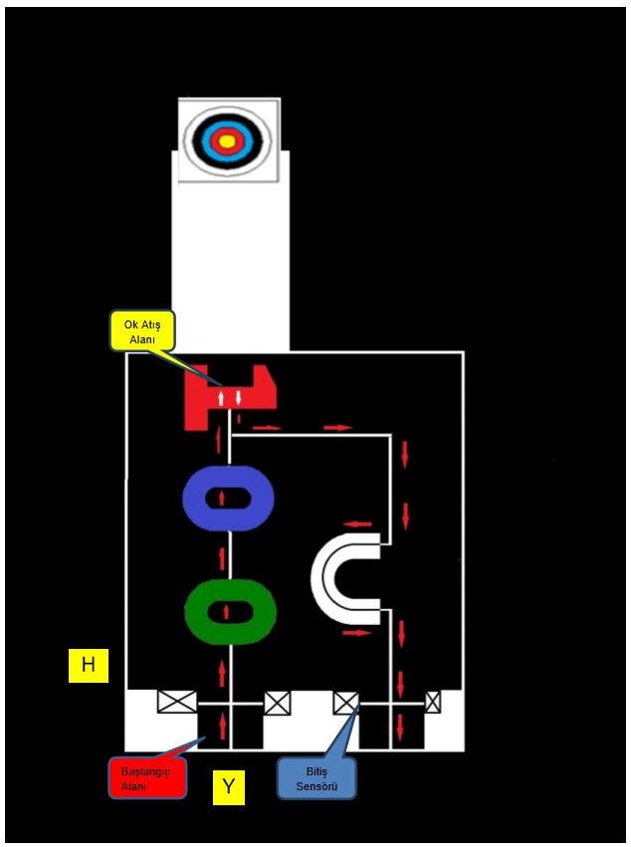
Figure-5: first round’s route and Robot movements

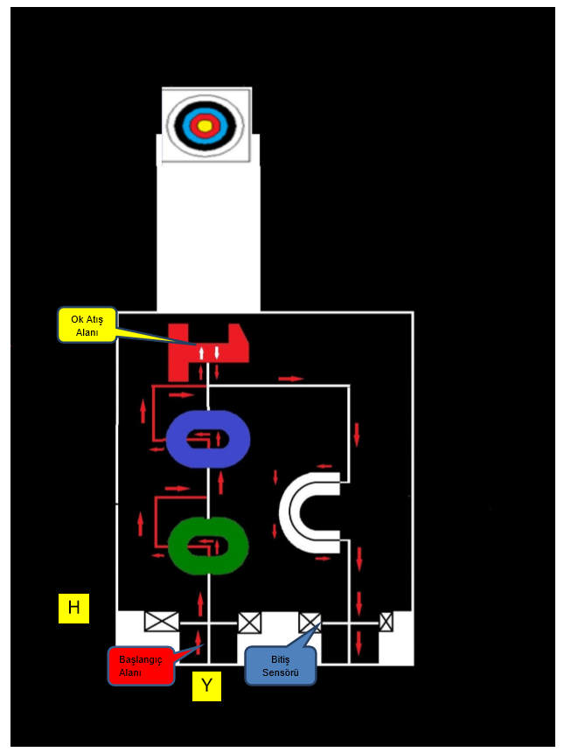
Figure-6: 2nd and 3th round’s route and Robot movements
Shooting area
B
Starting area

6.Other rules
- Any time for break or maintenance will not given to the teams.
- It is not allowed to put any sign or mark permenantly on the game platform or to damage it. Robots which damage platform will be disqualified.
- Robots can use any harmless energy source.
- In case of remote communication with robot, it will be disqualified.
- Red opaque foils, blue opaque foils and green opaque foils will be used for colored places.
- This elimination progress will continue like 16,8,4 etc. until remaining 2 robots. These two robots will be race for becoming winner. Their rivals will race again for third place.
- Game board dimensions can be changed slightly if it is necessary.
- Any objection related with lighting , camera or led boards will be refused.
- Competition organisation comittee has rights to make all kinds of modifications about the rules of contest in case of necessaries.

EVALUATION TABLE
ROBOT NAME | MANUAL INTERVENTION |  |  |  |  | STARTING  (BASE POINT ) | 1. STEP |  | 2.STEP |  | 3. STEP |  |  | 4. STEP |  |  | 5. STEP |  |  | TARGET BOARD (0-100 POINT ) | 6. STEP |  |  | 7. STEP |  | STOPWATCH TİME | FAILURE POINTS | TOTAL
 |  |  |  |  |  |  | START |  | GOING ON WHITE LİNE |  | GREEN |  |  | BLUE |  |  | RED |  |  |  | SHOOT |  |  | ZONE C
 |  |  |  |  |  |  |  |  |  |  | ZONE |  |  | ZONE |  |  | ZONE |  |  |  | ZONE |  |  | Ç. BİTİŞ
 |  |  |  |  |  |  | 10 POINT |  | 15 POINT |  | 15 POINT |  |  | 15 POINT |  |  | 15 POINT |  |  |  | 15 POINT |  |  | 15 POINT
 |  |  |  |  |  |  | Manual intevention | point | Manual intevention | point | Manual intevention | No led light up | point | Manual intevention | No led light up | point | Manual intevention | No shoot | point | point | Manual intevention | No led light up | point | Manual intevention | point
 |  |  |  |  |  | 100 | -5 | 10 | -5 | 15 | -5 | -5 | 15 | -5 | -5 | 15 | -5 | -5 | 15 |  | -5 | -5 | 15 | -5 | 15

